

​​
Advanced Programming
40201200
T/618/4902
Section (1)

Advanced Programming report

Submitted to
Sultan Alrushdan
Submitted by
Obada Al-Halaybeh

Spring –2025

Task 1
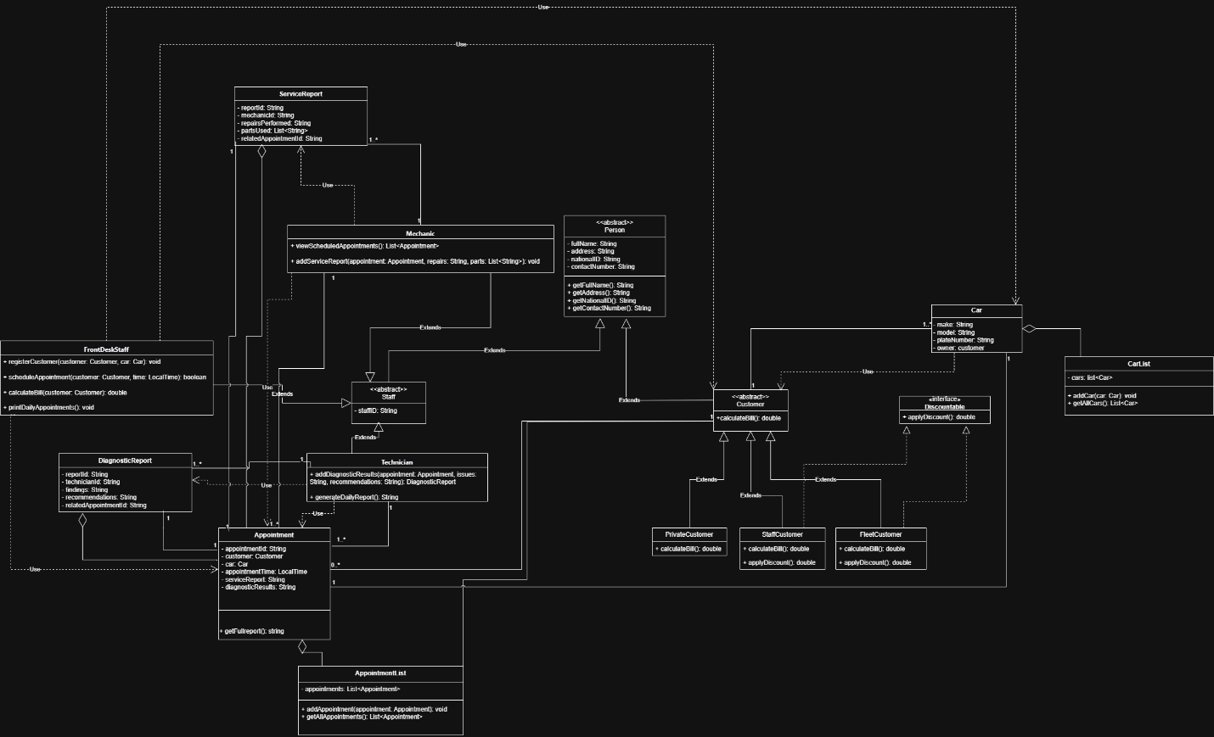

Task 2
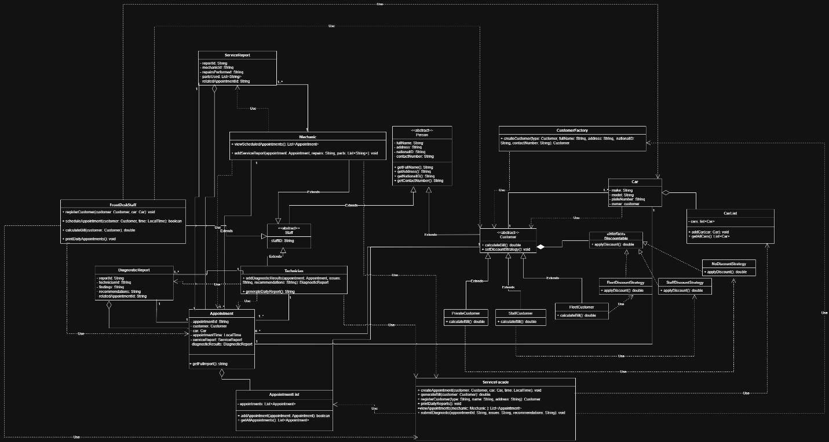

Task 3
The purpose of this test plan is to verify that the Car Maintenance and Repair Center Management System is accurate and dependable. The strategy focuses on important features and offers test cases to confirm anticipated behavior in a range of scenarios.
First functionality is the customer registration
Test case id | Input | Expected output | Description
1.1 | Full Name: “Ali”  Address: “Amman”  National ID: “1234”  Contact: “0799…”  Car: “Toyota Corolla 2015” | Customer object is created and stored successfully | Valid registration with full details
1.2 | Missing name | Error message displayed | Handles invalid or incomplete input
1.3 | Register a customer with a car missing a plate number | Error message | Ensures that car details are validated during registration

Second functionality is appointment scheduling
Test case id |  | Input | Expected output | Description
2.1 | Register a customer and schedule at 10:00 AM |  | Appointment is scheduled successfully | Valid case within working hours
2.2 | Schedule appointment at 6:00 PM |  | Error message | Validates working hour boundaries
2.3 | Schedule two appointments at 1:00 PM |  | shows conflict error | Ensures only one car per hour is allowed

Third functionality is bill calculations
Test case id |  | Input | Customer type | Expected output | Description
3.1 | Base Service Fee: 50 |  | Fleet customer | 35 JD (30% discount applied) | Discount correctly applied for fleet clients
3.2 | Base Service Fee: 50 |  | Staff customer | 25 JD (50% discount applied) | Discount correctly applied for staff
3.3 | Base Service Fee: 50 |  | Private customer | 50 JD (no discount) | No discount applied for regular customers

Task 4
- First the creational design pattern: factory pattern.
It was used in class customerFactory, its purpose is to create instance of different customers (the 3 types) based on the input, the why behind it is to hide the object creation logic from the clint (the front desk staff) making the code flexible and scalable.
For the advantages this will allow of the addition of new customer types without changing existing creation code like if I wanted to add new type of customers it will be just add new class and update the factory without altering anything else, it also support open closed principle.
- Second is the structural design pattern: façade pattern
It was used in class serviceFacade, the purpose of it is to act like a unified interface to the important functions like registering customers, scheduling appointments and so on, the why for this pattern usage is to simplify the user interface with the subsystems (appointment, reports)
For the advantages it make the system easier to use instead of calling different classes separately I can just call the façade and it dose every thing, it also hide complexity since It protects other parts of the system (staff classes) from the internal complexity of how things are stored or processed.
- Third is the behavioral design pattern: strategy pattern
I was used in the class discountable interface and the implementations NoDiscountStrategy, FleetDiscountStrategy and StaffDiscountStrategy, how it is used is each customer type use different discount strategy by calling applayDiscount through the common interface, the why is to encapsulate different discount behaviors and allow them to be used interchangeably without altering the customer class.
For the advantages of the strategy is making the discount logic flexible since if I want to change how the discount is calculated in customer type I can do that with only touching one class, I can also reuse this discount classes anywhere in the system without repeating the code and the most important is polymorphism since the system can handle all discount types using one interface.

Task 5
This task is code

Task 6
- SOLD principles used
Single responsibility principle (SRP) in my system each class has one clear responsibility like Customer holds the data and apply discounts, the appointment manga appointments data and reports and each type of the staff performs staff specific task only related to him all of this make the system easier to manage and test.
Open closed principle (OCP) the system can be extended without modifying the existing code, I can add new customer type by creating a subclass and add new case to the customer factory also I can add new discount without touching the customer class by implementing discountable interface.
Liskov substitution principle (LSP) all subclasses of Customer and Staff can be used interchangeably wherever their parent types are expected.
Interface segregation principle (ISP) in my system I have interface with only one method this ensure no fat interface and the classes that implements the interface only use what they need.
Dependency inversion principle (DIP) The Customer class depends on the abstraction Discountable instead of concrete discount classes. This allows me to change the discount logic without touching the customer logic.
- Clean code
Function names should say what they do: All classes and methods are named clearly like (calculateBill(), viewScheduledAppointments()).
Functions should do one thing: Each method performs one specific task to reduce complexity.
Use meaningful and pronounceable variable names: Variables like appointmentTime, contactNumber, and partsUsed are clear, descriptive, and easy to understand.
Use explanatory variables: In loops and method calls, I used variables like appointment, mechanic, customer, and technician instead of vague names like a or x. This improves readability.
- Design patterns used
factory pattern: used in customer factory its used for centralized and simplified customer creation. Easy to add new types.
Strategy Pattern: used at discountable with the 3 discount strategy classes I used it because the discount logic is separated and reusable. Can easily extend behavior.
Facade Pattern: used at service façade it provides one access point for main system functions, reducing UI complexity.

Task 7
This task was implemented as code

Task 8

A
JUnit 5 was the primary tool I used in this project to implement automatic testing, task 3 test plan was transformed into unit tests that addressed:
- Customer registration
- Appointment scheduling
- Bill calculation with discounts
Each test method was created using @Test annotations, and @BeforeEach was used to prepare reusable test objects and the expected behavior was verified using assertions.
I used assertEquals() to compare expected vs actual values, then assertTrue/Flase() to check for conditions like slot availability and the @BeforeEach was used to initialize data consistently.
Overall by using this method, I was able to automatically verify business logic and mimic important user actions without executing the entire application.

B
I will be discussing the differences between developer produced and vendor provided based on features like scope, customization, cost, integration and learning curve.
It will be shown in the table below:
Feature | Developer-produced | Vendor-Provided
Scope | Focuses on unit-level code testing | Can include UI and API, performance
Customization | Highly customizable by the developer | Often based on predefined frameworks and workflows
Cost | Free | Many vendor tools require licenses or subscriptions (not all of them)
Integration | Easily integrated in codebase | Some tools may require setup
 | Easier for developers already writing code | Often visual-based, easier for QA
  Learning Curve
example | JUnit, TestNG, PyTest | Selenium, Postman, TestComplete

Because JUnit is lightweight, integrates well with my Java code, and is ideal for directly testing class behavior and business logic, I decided to use it for this project.

C
There are numerous varieties of automatic testing, each with unique advantages and disadvantages. Unit testing, which concentrates on testing distinct components like the billing logic or appointment scheduling rules, was the primary methodology I used for this project. Unit testing has the advantages of being quick, simple to write, and providing instant feedback in the event that a method fails. For instance, I used a straightforward unit test to see if a StaffCustomer receives the appropriate discount, and it verified that the logic is sound without requiring the entire program to be executed. On the other hand, unit tests don't examine how various classes interact with one another. Integration testing would be more helpful in this situation. For example, I would need integration tests that replicate the entire customer registration, car linking, and booking an appointment process from start to finish if I wanted to test it. Another form of testing is UI testing which examines the system's behavior from the viewpoint of the user. Although they are slower and more difficult to use, tools like Selenium can mimic clicks and inputs. Overall, unit testing worked well for my system's logic-heavy components, but if the system were bigger or linked to a database or graphical user interface (GUI), integration testing would provide better overall coverage.

Reference
www.linkedin.com. (n.d.). How do you evaluate different test automation tools and vendors? [online] Available at: https://www.linkedin.com/advice/0/how-do-you-evaluate-different-test-automation-tools.
GeeksforGeeks (2019). Automation Testing Software Testing. [online] GeeksforGeeks. Available at: https://www.geeksforgeeks.org/automation-testing-software-testing/#advantages-of-automation-testing [Accessed 5 Jun. 2025].
Gillis, A. (2023). What is Automated Testing and How Does it Work? [online] SearchSoftwareQuality. Available at: https://www.techtarget.com/searchsoftwarequality/definition/automated-software-testing.
AWS (2024). What is Unit Testing? - Unit Testing Explained - AWS. [online] Amazon Web Services, Inc. Available at: https://aws.amazon.com/what-is/unit-testing/.
‌IBM (2025). Integration testing. [online] Ibm.com. Available at: https://www.ibm.com/think/topics/integration-testing.
‌

